
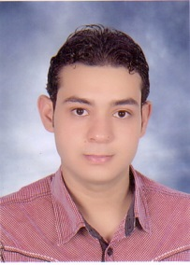
Abdel hakim hashmat abdel hakim

Abdel hakim28@yahoo.com



Education
PERSONAL DATA
- Date of Birth: 23/2/1992
- Gender : male
- Marital status: Single
- Nationality: Egyptian
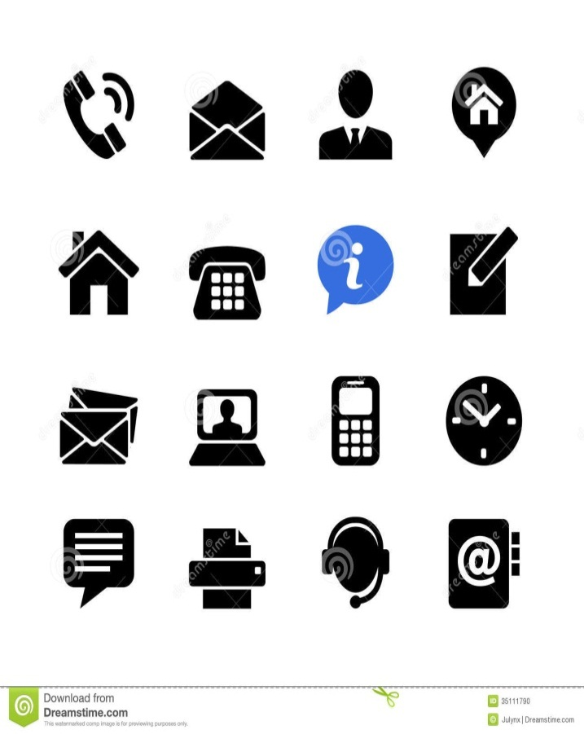
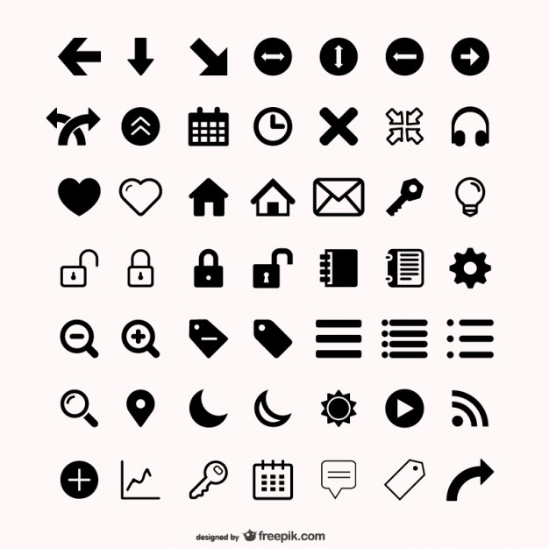
- Graduated from the Faculty of art, Assiut University, 2013

LANGUAES
- To obtain a good position that allows me to embody my ideas to reality with a major Corporation that lead to higher learning and skills improvement
- Improve the scientific and educational level of students and increase social awareness towards the issues and problems of society
- In addition to I am looking forward to enjoy working through a team work environment with like-mined thinkers.
OBJECTIVE
- Ability to work individually and as a co-operative team member
- Responsibility and Honesty.
- Able to work in a team .
- Good communication skills with the students
- Good knowledge of Microsoft Office (Word, Excel, PowerPoint, Access, Internet) and Data entry

PROFESSIONAL SKILLS

- Microsoft Office Good

- Arabic: Mother language
- English: Good

Computer SKILLS

